**Implementing computer vision application using a dataset .**

**Theory –**

The **vision.CascadeObjectDetector** implements the Viola-Jones algorithm for object detection, utilizing a series of steps to accurately identify objects within images. It begins by selecting Haar-like features from a training set, representing patterns of light and dark regions. These features are efficiently computed using integral image representation. Adaboost is then applied to select the most discriminative features, which are organized into a cascade of classifiers. Each classifier comprises multiple weak classifiers trained on distinct Haar-like features, enabling hierarchical filtering of image regions to swiftly discard non-object areas. Detection proceeds through a sliding window approach, with the cascade systematically evaluating features at various scales. Positive detections are produced when regions pass all cascade stages. To refine results, overlapping detections are merged, yielding final bounding boxes. To mitigate false positives, thresholding techniques and negative examples during training enhance classifier accuracy. In summary, the **vision.CascadeObjectDetector** effectively detects objects by leveraging Haar-like features, Adaboost, a cascade of classifiers, and careful thresholding, ensuring robust and accurate detection performance in diverse image datasets.Top of Form

**Code :**

**% Get the list of files in the folder**

folderPath = uigetdir; **% Select the folder containing the images**

files = dir(fullfile(folderPath, '*.jpg')); **% Get the list of jpg files**

**% Create a face detector object**

faceDetector = vision.CascadeObjectDetector;

faceDetector.MergeThreshold = 4;

**% Loop through each file in the folder**

for i = 1:length(files)

**% Get the file path**

filePath = fullfile(folderPath, files(i).name);

**% Read the image**

Img = imread(filePath);

**% Detect faces in the image**

bboxes = faceDetector(Img);

**% Check if faces were detected**

if ~isempty(bboxes)

**% Draw a rectangle around each face**

Imgf = insertObjectAnnotation(Img, 'rectangle', bboxes, 'Face', 'LineWidth', 3);

**% Display the image with faces detected**

imshow(Imgf);

title('Detected faces');

else

**% Display the image with no faces detected**

position = [0 0]; **% [xy]**

label = 'No face Detected';

Imgn = insertText(Img, position, label, 'FontSize', 25, 'BoxOpacity', 1);

imshow(Imgn);

end

**% Wait for a key press before moving on to the next image**

waitforbuttonpress;

end

**OUTPUT :**

**Original Image Face Detected Image**

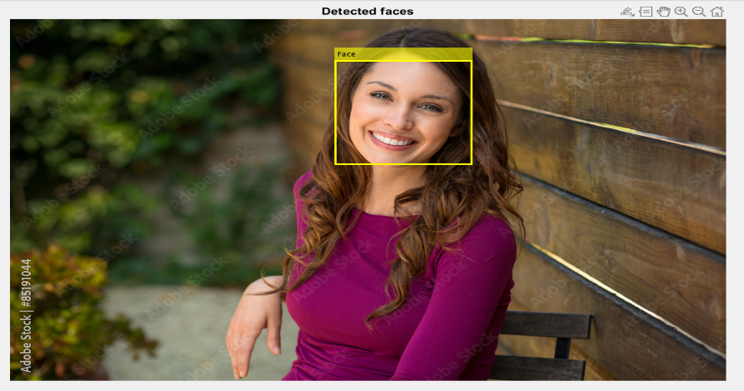

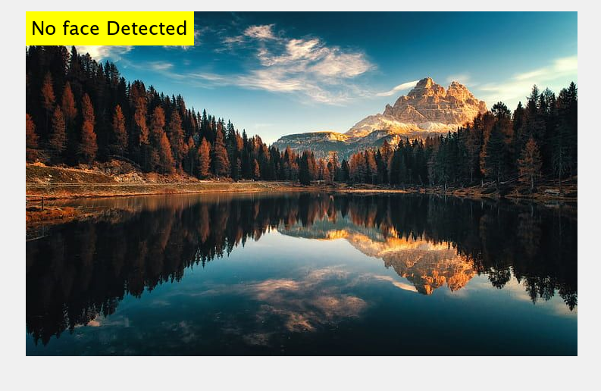

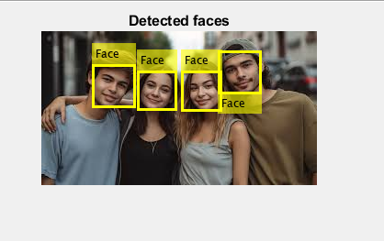

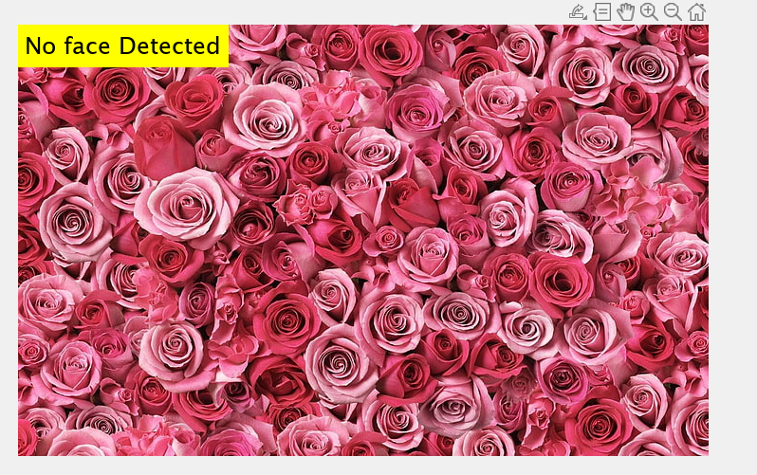

**Observation :**

Observations for object detection :

1. **Efficient Detection**: It utilizes the Viola-Jones algorithm, which is known for its efficiency in detecting objects within images.
2. **Pretrained Models**: It typically comes with pretrained models for common objects such as faces, which simplifies the implementation process.
3. **Configurability**: It allows for some configuration parameters to be adjusted, such as the merge threshold in the example provided, which can impact the detection performance.
4. **Usage**: It's relatively easy to use, making it suitable for both beginners and experienced users in computer vision applications.
5. **Performance**: While it performs well in many scenarios, its performance can vary based on factors like image quality, lighting conditions, and object size.
6. **Limitations**: Like any object detection method, it may struggle with certain types of images, complex backgrounds, or occlusions.